**vOS LAB**

S Vamsi Krishna

21BCE8152

1) Implementation of Memory Management Using Segmentation

*Note: Use C or Java Code to implement above Program.

Input:

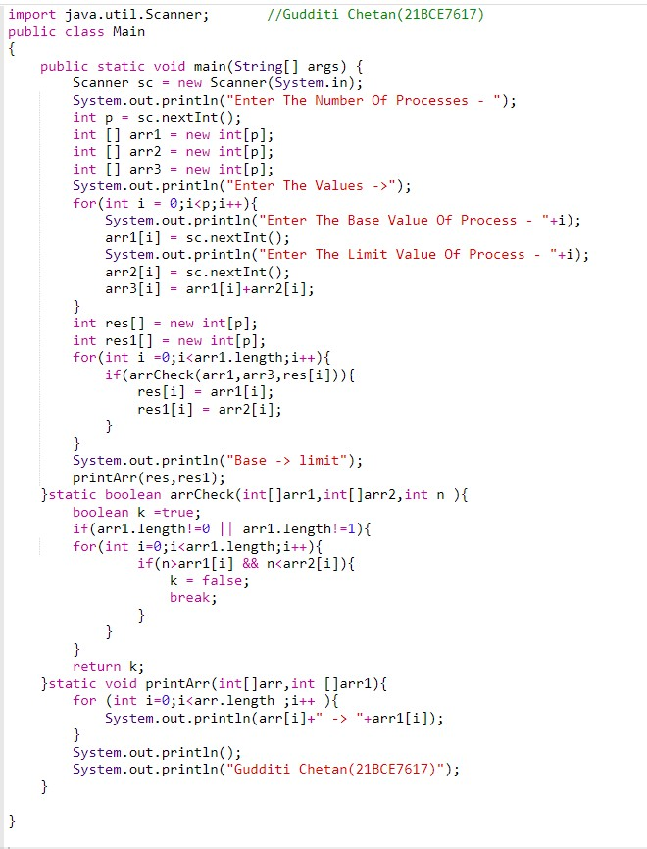



Output:

